

Inferential Statistics

Business Report 2024



Problem 1 5

About data 6

1.1 What is the probability that a randomly chosen player would suffer an injury? 6

1.2 What is the probability that a player is a forward or a winger? 6

1.3 What is the probability that a randomly chosen player plays in a striker position and has a foot injury? 6

1.4 What is the probability that a randomly chosen injured player is a striker? 6

Problem 2 7

About Data 7

Methodology 7

Assumptions 7

2.1 What proportion of the gunny bags have a breaking strength of less than 3.17 kg per sq cm? 7

2.2 What proportion of the gunny bags have a breaking strength of at least 3.6 kg per sq cm.? 8

2.3 What proportion of the gunny bags have a breaking strength between 5 and 5.5 kg per sq cm.? 9

2.4 What proportion of the gunny bags have a breaking strength NOT between 3 and 7.5 kg per sq cm.? 11

Problem 3 12

About data 13

3.1 Zingaro has reason to believe that the unpolished stones may not be suitable for printing. Do you think Zingaro is justified in thinking so? 13

1. Formulate Hypotheses 13

2. Calculate the level of significance 14

3. Select the appropriate test 14

4. Determine the test statistic and p-value 14

5. Compare the p-value 14

6. Conclusion 14

3.2 Is the mean hardness of the polished and unpolished stones the same? 15

1. Formulate Hypotheses 15

2. Calculate the level of significance 15

3. Select the appropriate test 16

4. Determine the test statistic and p-value 16

5. Compare the p-value 16

6. Conclusion 16

Problem 4 17

About Data 17

Treatment of data 17

Assumptions of ANOVA test 17

4.1 How does the hardness of implants vary depending on dentists? 18

Alloy-1 18

1. Formulate Hypotheses 18

2. Calculate the level of significance 18

3. Select the appropriate test 18

4. Conducting Shapiro-Wilks Test 18

5. Conducting Levene’s Test 18

6. Determine the p-value using f_oneway test 19

7. Compare the p-value 19

8. Conclusion 19

Alloy-2 19

1. Formulate Hypotheses 19

2. Calculate the level of significance 19

3. Select the appropriate test 19

4. Conducting Shapiro-Wilks Test 19

5. Conducting Levene’s Test 20

6. Determine the p-value using f_oneway test 20

7. Compare the p-value 20

8. Conclusion 20

4.2 How does the hardness of implants vary depending on methods? 20

Alloy-1 20

1. Formulate Hypotheses 20

2. Calculate the level of significance 21

3. Select the appropriate test 21

4. Conducting Shapiro-Wilks Test 21

5. Conducting Levene’s Test 21

6. Determine the p-value using f_oneway test 21

7. Compare the p-value 21

8. Conclusion 22

Alloy - 2 22

1. Formulate Hypotheses 22

2. Calculate the level of significance 22

3. Select the appropriate test 22

4. Conducting Shapiro-Wilks Test 22

5. Conducting Levene’s Test 22

6. Determine the p-value using f_oneway test 23

7. Compare the p-value 23

8. Conclusion 23

4.3 What is the interaction effect between the dentist and method on the hardness of dental implants for each type of alloy? 23

Inferences for Interaction plot for Alloy 1 24

Inferences for Interaction plot for Alloy 2 25

4.4 How does the hardness of implants vary depending on dentists and methods together? 26

Alloy-1 26

1. Formulate Hypotheses 26

2. Calculate the level of significance 26

3. Select the appropriate test 26

4. Conducting Shapiro-Wilks Test 26

5. Conducting Levene’s Test 26

6. Determine the p-value using AOV table 27

7. Compare the p-value 27

8. Conclusion 27

9. Tukey HSD inference 27

Alloy-2 28

1. Formulate Hypotheses 28

2. Calculate the level of significance 28

3. Select the appropriate test 28

4. Conducting Shapiro-Wilks Test 28

5. Conducting Levene’s Test 28

6. Determine the p-value using AOV table 29

7. Compare the p-value 29

8. Conclusion 29

9. Tukey HSD inference 29

Table of Figure

Figure 1 Breaking strength of gunny bags less than 3.17 kg per sq.cm. 9

Figure 2 Breaking strength of gunny bags atleast 3.6 kg per sq.cm. 10

Figure 3 Breaking strength of gunny bags between 5kg per sq.cm. and 5.5 kg per sq.cm. 11

Figure 4 Breaking strength of gunny bags Not between 3 kg per sq.cm. and 7.5 kg per sq.cm. 13

Figure 5 Normal Distribution of Brinell's Hardness Index for Unpolished Stones 15

Figure 6 Normal distribution of Same average of Brinell’s Hardness Index 17

Figure 7 Interaction Plot for Alloy 1 : Dentist vs Method 24

Figure 8 Interaction plot for Alloy 2: Dentist vs Method 25

### Problem 1

A physiotherapist with a male football team is interested in studying the relationship between foot injuries and the positions at which the players play from the data collected.

| Group | Striker | Forward | Attacking Midfielder | Winger | Total |
| --- | --- | --- | --- | --- | --- |
| Players Injured | 45 | 56 | 24 | 20 | 145 |
| Players Not Injured | 32 | 38 | 11 | 9 | 90 |
| Total | 77 | 94 | 35 | 29 | 235 |

#### 

#### About data

The data table summarizes the number of football players who are injured and not injured, categorized by their playing position. The positions include striker, forward, attacking midfielder and winger. There is an overall player of 235 in the table collected by the physiotherapist.

#### 1.1 What is the probability that a randomly chosen player would suffer an injury?

P(Injured player) = Players injured / Total number of players = 145 / 235 = 0.6170

The probability that a randomly chosen player would suffer an injury is 61.70%.

#### 1.2 What is the probability that a player is a forward or a winger?

P(Forward or Winger) = Players in forward or winger / Total number of players = (94 + 29)/235 = 123/235 = 0.5234

The probability that a player is a forward or winger will be 52.34%.

#### 1.3 What is the probability that a randomly chosen player plays in a striker position and has a foot injury?

P(Striker and injury) = Injured players in striker position / Total number of players = 45/235 = 0.1915

Probability that a randomly chosen player plays in the striker position and has a foot injury is 19.15%.

#### 1.4 What is the probability that a randomly chosen injured player is a striker?

P(Injured player in Striker) = Injured players in striker position / Total number of injured players = 45/145 = 0.3103

Probability that a randomly chosen injured player is a striker is 31.03%.

### Problem 2

The breaking strength of gunny bags used for packaging cement is normally distributed with a mean of 5 kg per sq. centimeter and a standard deviation of 1.5 kg per sq. centimeter. The quality team of the cement company wants to know the following about the packaging material to better understand wastage or pilferage within the supply chain; Answer the questions below based on the given information

#### About Data

The data provided is based on the breaking strength of the gunny bags which is used in packaging. The Mean (mu) is 5 kg per sq. cm. and the standard deviation (sigma) is 1.5 kg per sq.cm. It helps the quality team to understand the strength of the gunny bags and ensure if it falls below or above the threshold limit.

#### Methodology

Firstly we use the Z test with the help of value of interest, mean and standard deviation. Subsequently, we use the cumulative probability function to understand the probability of the event.

#### Assumptions

1. The data follows a normal distribution.
2. Sample values are independent of each other.
3. Sample size is greater than 30 and will be sufficiently large.
4. Sample comes from the same distribution.
5. The data is from a random sampled data.

#### 2.1 What proportion of the gunny bags have a breaking strength of less than 3.17 kg per sq cm?

Z test

Z - test = (X - (mu)) / sigma = (3.17 - 5) / 1.5 = -1.22

This means that the proportion of gunny bags having breaking strength less than 3.17 kg per sq. cm. is -1.22 scores away from the mean breaking strength.

Cumulative Probability

The cumulative probability of -1.22 is 0.1112.

Conclusion

The probability of gunny bags having a breaking strength of less than 3.17 kg per sq.cm. is 11.12%.

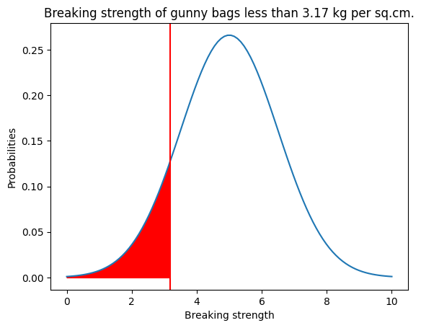

Figure 1 Breaking strength of gunny bags less than 3.17 kg per sq.cm.

#### 2.2 What proportion of the gunny bags have a breaking strength of at least 3.6 kg per sq cm.?

Z test

Z - test = (X - (mu)) / sigma = (3.6 - 5) / 1.5 = -0.93

This means that the proportion of gunny bags having breaking strength at least 3.6 kg per sq. cm. is -0.93 scores away from the mean breaking strength.

Cumulative Probability

The cumulative probability of -0.93 is 0.8247.

Conclusion

The probability of gunny bags having a breaking strength of at least 3.6 kg per sq.cm. is 82.47%.

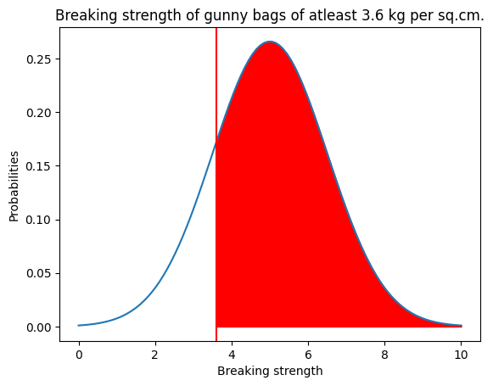

Figure 2 Breaking strength of gunny bags atleast 3.6 kg per sq.cm.

#### 2.3 What proportion of the gunny bags have a breaking strength between 5 and 5.5 kg per sq cm.?

Z test for 5 kg per sq.cm.

Z - test = (X - (mu)) / sigma = (5 - 5) / 1.5 = 0

This means that the proportion of gunny bags having breaking strength of 5 kg per sq. cm. is 0 scores away from the mean breaking strength.

Cumulative Probability

The cumulative probability of 0 is 0.50.

Z test for 5.5 kg per sq.cm.

Z - test = (X - (mu)) / sigma = (5.5 - 5) / 1.5 = 0.33

This means that the proportion of gunny bags having breaking strength of 5.5 kg per sq. cm. is 0.33 scores away from the mean breaking strength.

Cumulative Probability

The cumulative probability of 0.33 is 0.63.

Intersection value

We need to get the probability value of more than 5 kg per sq.cm. and probability value of less than 6 kg per sq.cm. Hence we subtract the cumulative probability of 5.5 kg per sq.cm. And cumulative probability of 5 kg per sq.cm.

The value would come to 0.1306.

Conclusion

The probability of gunny bags having a breaking strength between 5 and 5.5 kg per sq cm. Is 13.06%.

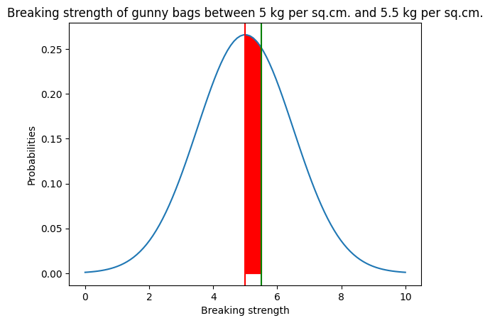

Figure 3 Breaking strength of gunny bags between 5kg per sq.cm. and 5.5 kg per sq.cm.

#### 2.4 What proportion of the gunny bags have a breaking strength NOT between 3 and 7.5 kg per sq cm.?

Z test for 3 kg per sq.cm.

Z - test = (X - (mu)) / sigma = (3 - 5) / 1.5 = -1.33

This means that the proportion of gunny bags having breaking strength of 3 kg per sq. cm. is -1.33 scores away from the mean breaking strength.

Cumulative Probability

The cumulative probability of -1.33 is 0.0912.

Z test for 7.5 kg per sq.cm.

Z - test = (X - (mu)) / sigma = (7.5 - 5) / 1.5 = 1.67

This means that the proportion of gunny bags having breaking strength of 7.5 kg per sq. cm. is 1.67 scores away from the mean breaking strength.

Cumulative Probability

The cumulative probability of 1.67 is 0.0478.

Intersection value

We need to get the probability value of less than 3 kg per sq.cm. and probability value of more than 7.5 kg per sq.cm. Hence we add the cumulative probability of 3 kg per sq.cm. And cumulative probability of 7.5 kg per sq.cm.

The value would come to 0.1390.

Conclusion

The probability of gunny bags having a breaking strength NOT between 3 and 7.5 kg per sq cm. Is 13.90%.

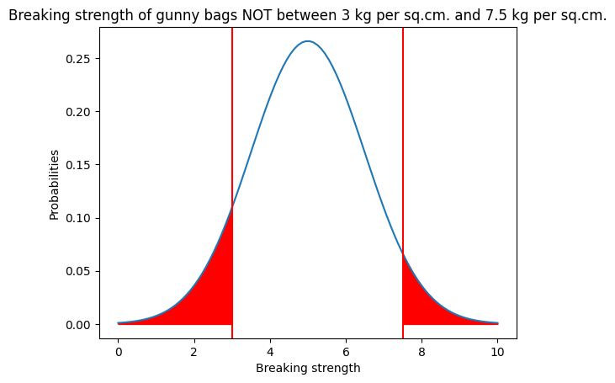

Figure 4 Breaking strength of gunny bags Not between 3 kg per sq.cm. and 7.5 kg per sq.cm.

### Problem 3

Zingaro stone printing is a company that specializes in printing images or patterns on polished or unpolished stones. However, for the optimum level of printing of the image, the stone surface has to have a Brinell's hardness index of at least 150. Recently, Zingaro has received a batch of polished and unpolished stones from its clients. Use the data provided to answer the following (assuming a 5% significance level);

#### About data

The data provided concerns the Brinell’s hardness index of stones used by Zingaro Stone Printing. The hardness index is crucial because the stones need to have a minimum Brinell’s hardness index of 150 to be suitable for optimal printing.

The dataset includes hardness indices for both unpolished and polished stones. There are a total of 75 rows and 2 columns in the dataset.

While doing the primary analysis we can observe that the average Brinell’s hardness index of unpolished stone is 134.11 and for treated and polished stone it averages to 147.79. The minimum Brinell’s hardness index for unpolished stone and treated and polished stone is 48.40 and 107.52 respectively and maximum is 200.16 and 192.27 respectively.

#### 3.1 Zingaro has reason to believe that the unpolished stones may not be suitable for printing. Do you think Zingaro is justified in thinking so?

Let’s follow a step by step approach to justify the claim by Zingaro.

##### Formulate Hypotheses

We would create a null hypothesis (H0) and an alternative hypothesis (Ha). A null hypothesis will be the current scenario whereas the alternative hypothesis will be the claimed scenario.

In this case let's formulate the null and alternative hypothesis.

H0: The mean Brinell’s hardness index of unpolished stones is atleast 150.

(μ>=150)

Ha: The mean Brinell’s hardness index of unpolished stones is less than 150.

(μ<150)

##### Calculate the level of significance

The level of significance is set at 5%.

##### Select the appropriate test

Since the standard deviation is not known and only one sample is being tested here, we would opt for t-test for 1 sample.

Assumptions

1. The data collected is independent.
2. The distribution should be a normal distribution.
3. It is continuous data.
4. The sample is taken on a random basis from the population.

##### Determine the test statistic and p-value

The test statistic value is -4.16 and the p value derived from the test is 0.000041.

##### Compare the p-value

The p-value is less than the level of significance. (0.000041 < 0.05)

##### Conclusion

We have enough statistical evidence to reject the null hypothesis. Hence, the unpolished stone has Brinell’s hardness index less than 150 and justifies the belief of Zingaro that the stone might be unsuitable for printing.

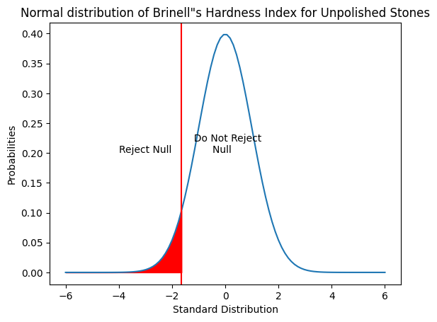

Figure 5 Normal Distribution of Brinell's Hardness Index for Unpolished Stones

#### 3.2 Is the mean hardness of the polished and unpolished stones the same?

##### Formulate Hypotheses

We would create a null hypothesis (H0) and an alternative hypothesis (Ha). A null hypothesis will be the current scenario whereas the alternative hypothesis will be the claimed scenario.

In this case let's formulate the null and alternative hypothesis.

H0: The mean hardness of the polished and unpolished stones are same (μ0=μ1)

Ha: The mean hardness of the polished and unpolished stones are different (μ0≠μ1)

##### Calculate the level of significance

The level of significance is set at 5%.

##### Select the appropriate test

Since the standard deviation is not known and two samples are being tested here, we would opt for t-test for independent variables.

##### Determine the test statistic and p-value

The test statistic value is -3.24 and the p value derived from the test is 0.0016.

##### Compare the p-value

The p value is less than level of significance

##### Conclusion

We have enough statistical evidence to reject the null hypothesis. This means that the average of Brinell’s hardness index for unpolished and treated and polished stones are significantly different.

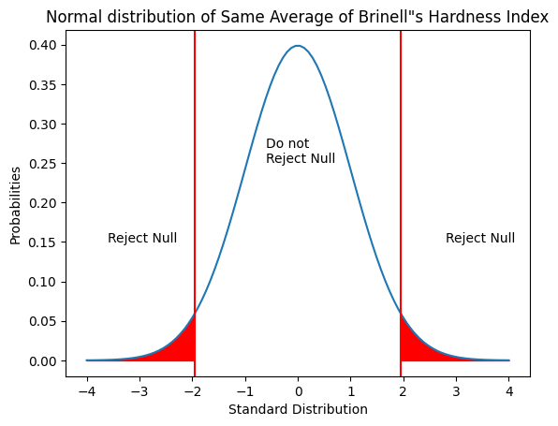

Figure 6 Normal distribution of Same average of Brinell’s Hardness Index

### Problem 4

Dental implant data: The hardness of metal implants in dental cavities depends on multiple factors, such as the method of implant, the temperature at which the metal is treated, the alloy used as well as the dentists who may favor one method above another and may work better in his/her favorite method. The response is the variable of interest.

#### About Data

The given dataset pertains to a study on the hardness of metal implants used in dental cavities. The response is considered to be the variable of interest or dependent variable.

1. Dentist: These are the specific dentist performing the procedure and is a categorical variable. There are five dentists in the sample provided.
2. Method: This is the method used for dental implant. There are three methods used and is treated as a categorical variable.
3. Alloy: The type of alloy used for the implant. This is also a categorical variable and there are two types of alloys.
4. Temp: The temperature at which the metal alloy is treated. There are three categories under this column.
5. Response: The measured hardness of the implant. This is a numerical variable.

The objective is to use ANOVA (Analysis Of Variances) to check the influence of independent variables on response which is a dependent variable.

#### Treatment of data

We have created two data frames which are for Type 1 alloy and type 2 alloy.

#### Assumptions of ANOVA test

1. The sample follows a normal distribution.
2. The distribution has the same variance.
3. The observations in the sample are independent and are taken from a random sample.

#### 4.1 How does the hardness of implants vary depending on dentists?

##### Alloy-1

##### Formulate Hypotheses

The null hypothesis for ANOVA will always be that there will be no influence of independent variables on dependent variables. The alternative hypothesis will always be that there is an influence of independent variables on dependent variables.

Keeping this in mind, we can formulate the hypotheses as:

H0: There is no significant difference in the hardness of the implant depending on the dentists for Alloy 1

Ha: There is a significant difference in the hardness of implants depending on the dentists for Alloy 1

##### Calculate the level of significance

The level of significance is set at 5%.

##### Select the appropriate test

We use ANOVA to do the test on the sample because there are more than two samples which are being tested here and we use One way ANOVA.

##### Conducting Shapiro-Wilks Test

Formulating hypothesis:

H0: The response follows a normal distribution for Alloy 1

Ha: The response does not follow a normal distribution for Alloy 1

The level of significance is at 0.05

By conducting Shapiro - Wilks test finds that the p value is less than the level of significance. Hence we have enough statistical evidence to reject the null hypothesis. Therefore, the distribution does not follow normal distribution.

However, for the purpose of this project let us assume that the response follows a normal distribution.

##### Conducting Levene’s Test

Formulating hypothesis:

H0: The population variances are equal for Alloy 1

Ha: The population variances are not equal for Alloy 1

The level of significance is at 0.05

Levene's test finds that the p value is greater than the level of significance and we do not have enough statistical evidence to reject the null hypothesis. Therefore the variances are equal.

##### Determine the p-value using f_oneway test

By using the ANOVA method, we find that the p-value to be 0.1165.

##### Compare the p-value

Since p-value is greater than level of significance, we do not have enough statistical evidence to reject the null hypothesis. Therefore, we fail to reject the null hypothesis.

##### Conclusion

Since we fail to reject the null hypothesis, we can say that there is no significant difference in the hardness of the implants depending on the dentists for alloy 1.

##### Alloy-2

##### Formulate Hypotheses

The null hypothesis for ANOVA will always be that there will be no influence of independent variables on dependent variables. The alternative hypothesis will always be that there is an influence of independent variables on dependent variables.

Keeping this in mind, we can formulate the hypotheses as:

H0: There is no significant difference in the hardness of the implant depending on the dentists for Alloy 2

Ha: There is a significant difference in the hardness of implants depending on the dentists for Alloy 2

##### Calculate the level of significance

The level of significance is set at 5%.

##### Select the appropriate test

We use ANOVA to do the test on the sample because there are more than two samples which are being tested here and we use One way ANOVA.

##### Conducting Shapiro-Wilks Test

Formulating hypothesis:

H0: The response follows a normal distribution for Alloy 2

Ha: The response does not follow a normal distribution for Alloy 2

The level of significance is at 0.05

By conducting the Shapiro - Wilks test finds that the p value is less than the level of significance. Hence we have enough statistical evidence to reject the null hypothesis. Therefore, the distribution does not follow normal distribution.

However, for the purpose of this project let us assume that the response follows a normal distribution.

##### Conducting Levene’s Test

Formulating hypothesis:

H0: The population variances are equal for Alloy 2

Ha: The population variances are not equal for Alloy 2

The level of significance is at 0.05

Levene's test finds that the p value is greater than the level of significance and we do not have enough statistical evidence to reject the null hypothesis. Therefore the variances are equal.

##### Determine the p-value using f_oneway test

By using the ANOVA method, we find that the p-value to be 0.7180.

##### Compare the p-value

Since p-value is greater than level of significance, we do not have enough statistical evidence to reject the null hypothesis. Therefore, we fail to reject the null hypothesis.

##### Conclusion

Since we fail to reject the null hypothesis, we can say that there is no significant difference in the hardness of the implants depending on the dentists for alloy 2.

#### 4.2 How does the hardness of implants vary depending on methods?

##### Alloy-1

##### Formulate Hypotheses

The null hypothesis for ANOVA will always be that there will be no influence of independent variables on dependent variables. The alternative hypothesis will always be that there is an influence of independent variables on dependent variables.

Keeping this in mind, we can formulate the hypotheses as:

H0: There is no significant difference in the hardness of the implant depending on the methods for Type 1 Alloy

Ha: There is a significant difference in the hardness of implants depending on the methods Type 1 Alloy

##### Calculate the level of significance

The level of significance is set at 5%.

##### Select the appropriate test

We use ANOVA to do the test on the sample because there are more than two samples which are being tested here and we use One way ANOVA.

##### Conducting Shapiro-Wilks Test

Formulating hypothesis:

H0: The response follows a normal distribution for Alloy 1

Ha: The response does not follow a normal distribution for Alloy 1

The level of significance is at 0.05

By conducting the Shapiro - Wilks test finds that the p value is less than the level of significance. Hence we have enough statistical evidence to reject the null hypothesis. Therefore, the distribution does not follow normal distribution.

However, for the purpose of this project let us assume that the response follows a normal distribution.

##### Conducting Levene’s Test

Formulating hypothesis:

H0: The population variances are equal for Alloy 1

Ha: The population variances are not equal for Alloy 1

The level of significance is at 0.05

Levene's test finds that the p value is less than the level of significance and we have enough statistical evidence to reject the null hypothesis. Therefore the variances are not equal.

However, for the purposes of the project we assume that the variances are equal.

##### Determine the p-value using f_oneway test

By using the ANOVA method, we find that the p-value to be 0.0041.

##### Compare the p-value

Since p-value is less than level of significance, we have enough statistical evidence to reject the null hypothesis.

##### Conclusion

Since we reject the null hypothesis, we can say that there is a significant difference in the hardness of the implants depending on the methods for alloy 1.

##### Alloy - 2

##### Formulate Hypotheses

The null hypothesis for ANOVA will always be that there will be no influence of independent variables on dependent variables. The alternative hypothesis will always be that there is an influence of independent variables on dependent variables.

Keeping this in mind, we can formulate the hypotheses as:

H0: There is no significant difference in the hardness of the implant depending on the methods for Type 2 Alloy

Ha: There is a significant difference in the hardness of implants depending on the methods Type 2 Alloy

##### Calculate the level of significance

The level of significance is set at 5%.

##### Select the appropriate test

We use ANOVA to do the test on the sample because there are more than two samples which are being tested here and we use One way ANOVA.

##### Conducting Shapiro-Wilks Test

Formulating hypothesis:

H0: The response follows a normal distribution for Alloy 2

Ha: The response does not follow a normal distribution for Alloy 2

The level of significance is at 0.05

By conducting the Shapiro - Wilks test finds that the p value is less than the level of significance. Hence we have enough statistical evidence to reject the null hypothesis. Therefore, the distribution does not follow normal distribution.

However, for the purpose of this project let us assume that the response follows a normal distribution.

##### Conducting Levene’s Test

Formulating hypothesis:

H0: The population variances are equal for Alloy 2

Ha: The population variances are not equal for Alloy 2

The level of significance is at 0.05

Levene's test finds that the p value is less than the level of significance and we have enough statistical evidence to reject the null hypothesis. Therefore the variances are not equal.

However, for the purposes of the project we assume that the variances are equal.

##### Determine the p-value using f_oneway test

By using the ANOVA method, we find that the p-value to be 0.00000541.

##### Compare the p-value

Since p-value is less than level of significance, we have enough statistical evidence to reject the null hypothesis.

##### Conclusion

Since we reject the null hypothesis, we can say that there is a significant difference in the hardness of the implants depending on the methods for alloy 2.

#### 4.3 What is the interaction effect between the dentist and method on the hardness of dental implants for each type of alloy?

We create interaction plots between method and hardness along in correspondence with the dentist. Interaction plots help to understand the interaction between variables. Non parallel lines signify that there is interaction between variables whereas the parallel lines would signify that there is no interaction between both.

##### Inferences for Interaction plot for Alloy 1

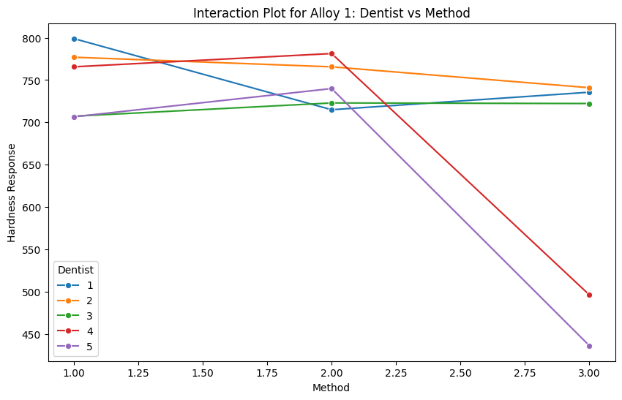

Figure 7 Interaction Plot for Alloy 1 : Dentist vs Method

* Dentist 1 shows a high hardness level under method 1 whereas there is a drop in method 2 and method 3.
* Dentist 2 shows a relatively stable response with a declining trend throughout the method 1 to method 3.
* Dentist 3 has a more consistent response level with an inclining line plot.
* Dentist 4 has a good hardness level in method 1 and method 2 but drastically dropped in method 3.
* Dentist 5 has a good hardness response in method 2 followed by method 1 and drastically drops for method 3.
* There are interactions between dentists throughout all the methods whereas for dentist 4 and dentist 5 there is no interaction in method 3.
* Analyzing the methods, method 1 generally yields a better hardness response specifically for dentist 1.
* Method 2 shows a varied response however, it is more stable in comparison to method 1 and method 3.
* Method 3 shows an issue with the dentists since it yields lower hardness response in lieu with type 1 alloy.
* In conclusion, we can see that there is a significant interaction in methods depending on individual dentists. Method 3 should be further investigated since it yields a lower hardness level throughout all the dentists.

##### Inferences for Interaction plot for Alloy 2

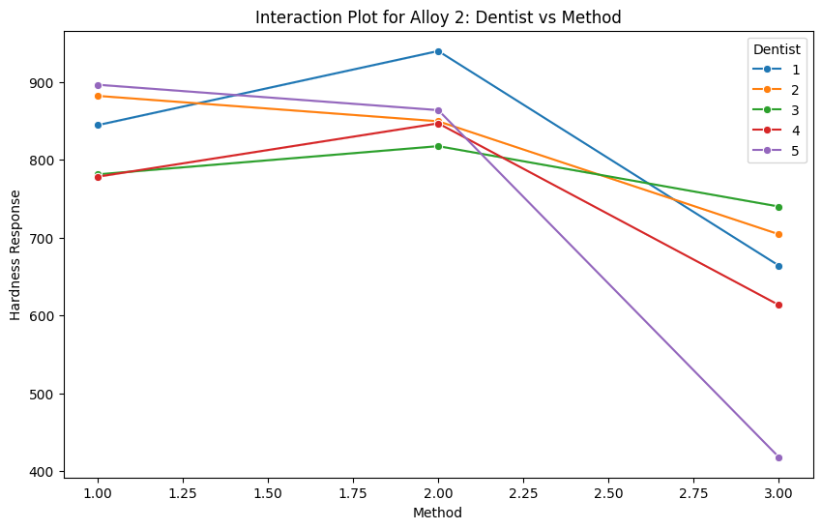

Figure 8 Interaction plot for Alloy 2: Dentist vs Method

* For dentist 1, the hardness response is high for method 2 under alloy 2 followed by method 1 and then dramatically falls for method 3.
* For dentist 2, there is a declining trend throughout the method 1 to method 3 where the highest is in method 1.
* Dentist 3 is relatively stable and has a slightly higher hardness response for method 2.
* Dentist 4 has a higher yield for hardness response method 2 and declines for method 1 and more declining trend for method 3.
* Dentist 5 has a good yield for hardness level in method 1 and method2 whereas it significantly drops for method 3.
* Analyzing the methods, there is an interaction in method 1 between dentist 3 and 4 and higher hardness response by dentist 2 and dentist 5.
* Method 2 has a better yield in terms of consistency, all dentists have a good yield between 800 to 900 whereas dentist 1 has a better yield of more than 900 in comparison to other dentists.
* Method 3 shows a significant drop by all dentists and should be further investigated.
* In conclusion, there is interaction between all the dentists throughout method 1 and method 2 whereas there is an issue with method 3 where there is no interaction and with lower yield on hardness response.

#### 4.4 How does the hardness of implants vary depending on dentists and methods together?

##### Alloy-1

##### Formulate Hypotheses

The null hypothesis for ANOVA will always be that there will be no influence of independent variables on dependent variables. The alternative hypothesis will always be that there is an influence of independent variables on dependent variables.

Keeping this in mind, we can formulate the hypotheses as:

H0: There is no significant effect in the hardness of the implant depending on the methods and dentists for Type 1 Alloy

Ha: There is significant effect in the hardness of the implant depending on the methods and dentists for Type 1 Alloy

##### Calculate the level of significance

The level of significance is set at 5%.

##### Select the appropriate test

We use ANOVA to do the test on the sample because there are more than two samples which are being tested here and testing for two variables. Hence, we use Two way ANOVA.

##### Conducting Shapiro-Wilks Test

Formulating hypothesis:

H0: The response follows a normal distribution for Alloy 1

Ha: The response does not follow a normal distribution for Alloy 1

The level of significance is at 0.05

By conducting the Shapiro - Wilks test finds that the p value is less than the level of significance. Hence we have enough statistical evidence to reject the null hypothesis. Therefore, the distribution does not follow normal distribution.

However, for the purpose of this project let us assume that the response follows a normal distribution.

##### Conducting Levene’s Test

Formulating hypothesis:

H0: The population variances are equal for Alloy 1

Ha: The population variances are not equal for Alloy 1

The level of significance is at 0.05

Levene's test finds that the p value is greater than the level of significance and we do not have enough statistical evidence to reject the null hypothesis. Therefore the variances are equal.

##### Determine the p-value using AOV table

By using the ANOVA method, we find that the p-value between the interaction of method and dentist is 0.0067.

##### Compare the p-value

Since p-value is less than level of significance, we have enough statistical evidence to reject the null hypothesis.

##### Conclusion

Since we reject the null hypothesis, we can say that there is a significant effect in the hardness of the implant depending on the methods and dentists for Type 1 Alloy.

##### Tukey HSD inference

Many comparisons between dentists and methods are shown as non significant differences since they fail to reject the null hypothesis. Thus, there is no interaction between dentists and methods used.

1_1 vs. 1_2 (p-val = 0.9933)

1_2 vs. 1_3 (p-val = 1.0)

2_1 vs. 2_2 (p-val = 1.0)

Whereas there also methods wherein the p value is less than level of significance and hence being able to reject the null hypothesis. Therefore signifying that there is an interaction between dentists and methods. Below are some of the interaction methods in lieu with the dentist.

In format of *dentist_method vs dentist_method*

2_2 vs. 4_3 (p-val = 0.0243)

3_1 vs. 5_3 (p-val = 0.0229)

4_1 vs. 4_3 (p-val = 0.0243)

Therefore, both the choice of dentist and the method used play crucial roles in determining the hardness of the dental alloy. Understanding these interactions can help in optimizing the procedures to achieve desired hardness levels.

##### Alloy-2

##### Formulate Hypotheses

The null hypothesis for ANOVA will always be that there will be no influence of independent variables on dependent variables. The alternative hypothesis will always be that there is an influence of independent variables on dependent variables.

Keeping this in mind, we can formulate the hypotheses as:

H0: There is no significant effect in the hardness of the implant depending on the methods and dentists for Type 2 Alloy

Ha: There is significant effect in the hardness of the implant depending on the methods and dentists for Type 2 Alloy

##### Calculate the level of significance

The level of significance is set at 5%.

##### Select the appropriate test

We use ANOVA to do the test on the sample because there are more than two samples which are being tested here and testing for two variables. Hence, we use Two way ANOVA.

##### Conducting Shapiro-Wilks Test

Formulating hypothesis:

H0: The response follows a normal distribution for Alloy 2

Ha: The response does not follow a normal distribution for Alloy 2

The level of significance is at 0.05

By conducting the Shapiro - Wilks test finds that the p value is less than the level of significance. Hence we have enough statistical evidence to reject the null hypothesis. Therefore, the distribution does not follow normal distribution.

However, for the purpose of this project let us assume that the response follows a normal distribution.

##### Conducting Levene’s Test

Formulating hypothesis:

H0: The population variances are equal for Alloy 2

Ha: The population variances are not equal for Alloy 2

The level of significance is at 0.05

Levene's test finds that the p value is greater than the level of significance and we do not have enough statistical evidence to reject the null hypothesis. Therefore the variances are equal.

##### Determine the p-value using AOV table

By using the ANOVA method, we find that the p-value between the interaction of the method and dentist is 0.093.

##### Compare the p-value

Since p-value is greater than level of significance, we do not have enough statistical evidence to reject the null hypothesis.

##### Conclusion

Since we fail to reject the null hypothesis, we can say that there is no significant effect on the hardness of the implant depending on the methods and dentists for Type 2 Alloy.

##### Tukey HSD inference

Since we do have enough statistical evidence to reject the null hypothesis we need not do the tukey HSD test.